**Answer 1**

We know from Bayes Theorem, where y is the data and θ represents the parameters of the model that will define the data y

P(θ|y) = (P(y|θ).P(θ)) / P(y)

=> P(θ|y) ∝ P(y|θ).P(θ) => P(θ|y) ∝ L(θ).P(θ) => Posterior ∝ Liklihood . Prior

From the question we know,

Prior is defined by P(θ) = Beta(α,β) = B(α,β)−1 . θα−1 . (1−θ)β−1

Likelihood function is defined by = Bin(ni,θ) = (niCyi) . θyi . (1−θ)ni−yi

Therefore, the posterior is given by   
∏( (niCyi) . θyi . (1−θ)ni−yi ).( B(α,β)−1 . θα−1 . (1−θ)β−1 )

=> P(θ|y1,,,,,,yn) ∝ (θ∑yi . (1−θ)∑(ni-yi)) x (θα−1 . (1−θ)β−1)

=> P(θ|y1,,,,,,yn) ∝ (θα + ∑yi -1 . (1−θ) β + ∑(ni-yi) -1)

=> P(θ|y1,,,,,,yn) ∝ (θα + ∑yi -1 . (1−θ) β + ∑(ni-yi) -1)

=> P(θ|y1,,,,,,yn) ∝ **Beta(α + ∑yi, β + ∑(ni-yi))** = Posterior Distribution

**Answer 2**

We know from Bayes Theorem, where y is the data and θ represents the parameters of the model that will define the data y

P(θ|y) = (P(y|θ).P(θ)) / P(y)

=> P(θ|y) ∝ P(y|θ).P(θ) => P(θ|y) ∝ L(θ).P(θ) => Posterior ∝ Liklihood . Prior

From the question we know,

Prior is defined by P(θ) = Beta(α,β) = B(α,β)−1 . θα−1 . (1−θ)β−1

Likelihood function is defined by = Geom(θ) = (1 − θ)y−1 . θ

Therefore, the posterior is given by   
∏( (1 − θ)yi−1 . θ).( B(α,β)−1 . θα−1 . (1−θ)β−1 )

=> P(θ|y1,,,,,,yn) ∝ (θn . (1−θ)∑(yi-1)) x (θα−1 . (1−θ)β−1)

=> P(θ|y1,,,,,,yn) ∝ (θα+n−1 . (1−θ)β + ∑(yi-1) -1)

=> P(θ|y1,,,,,,yn) ∝ **Beta(α+n,β + ∑(yi-1))** = Posterior Distribution

**Answer 3**

1. From Q1, we know that Posterior Distribution

P(θ|y1,,,,,,yn) ∝ Beta(α + ∑yi, β + ∑(ni-yi))

|  |  |  |
| --- | --- | --- |
| Treatment | Total (n) | Successes (y) |
| Placebo only | 160 | 30 |
| Nicotine Patch | 244 | 52 |
| Zyban | 244 | 85 |
| Zyban and Nicotine Patch | 245 | 95 |

Using the prior mentioned **θ∼Beta(1,1) where α = 1, β = 1**

The Posterior Distribution, becomes **P(θ|y) ∝ Beta(y + 1, n – y + 1)**

**For Placebo,** P(θ1|y1) ∝ Beta(30 + 1, 160 – 30 + 1) = **Beta(31, 131)**

**For Nicotine Patch,** P(θ2|y2) ∝ Beta(52 + 1, 244 – 52 + 1) = **Beta(53, 193)**

**For Zyban,** P(θ3|y3) ∝ Beta(85 + 1, 244 – 85 + 1) = **Beta(86, 160)**

**For Zyban and Nicotine Patch,** P(θ4|y4) ∝ Beta(95 + 1, 245 – 95 + 1) = **Beta(96, 151)**

1. When calculating the credible interval of 95% = 0.95

The alpha will be set to 1 – 95% = 1 – 0.95 = 0.05

For calculating the 95% credible interval, define the [lower limit, upper limit]

[lower limit, upper limit] = [alpha/2, 1 - alpha/2] = [0.025, 0.975]

To find the credible interval, we have used scipy **(Code attached in APPENDIX)**

|  |  |  |  |
| --- | --- | --- | --- |
| Group | Beta parameters | lower | upper |
| Placebo | (31, 131) | 0.134734 | 0.255194 |
| Nicotine | (53, 193) | 0.166444 | 0.268831 |
| Zyban | (86, 160) | 0.291345 | 0.410159 |
| zyban & nicotine | (96, 151) | 0.328908 | 0.450128 |

From the calculations, we can see that Bayesian credible interval and confidence interval lie close to each other. For the groups of placebo only and nicotine only, the credible interval is slightly bigger in scale. For zyban only group, the credible interval and confidence interval are same.

For the group of Zyban and nicotine patch the credible interval is wider than the confidence interval. When the credible interval is wider than the confidence interval, it means that the Bayesian method is incorporating more uncertainty because it includes prior information. This means the model is less sure of the estimated value. Hence it is presenting a wider range to cover all outcomes. This happens due to the data not being sure of the output value but we know that credible interval presents the true value given the data and the presented priors.

Hence, I agree with authors assumption that zyban only has the best success.

**Answer 4**

1. **(Code attached in APPENDIX)**
2. **(Code attached in APPENDIX)**
3. **(Code attached in APPENDIX)**

**Trace Plot**

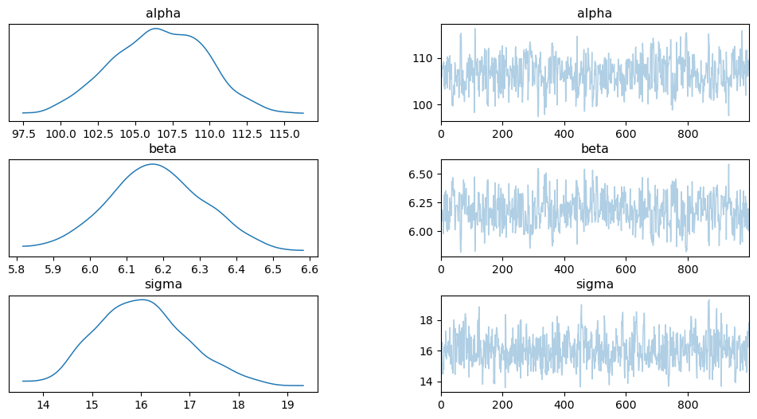

**Autocorrelation Plot**

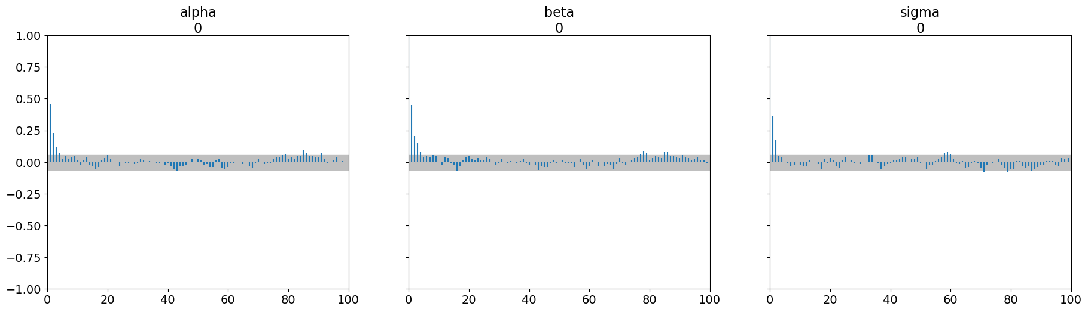

The trace plot show variability in the 3 parameters and also show that the parameter space is covered well. The existence of a unimodal structure also behaves well for the Posterior distribution. For the three parameters the graph shows no patterns as well as the fluctuations lie close to their respective means.

The bell-shaped curve shows that the 3 parameters have converged on a normal distribution as required for the Posterior distribution. This is good for convergence.

The autocorrelation plot shows the independence of the samples from each other. In case of autocorrelation plots the objective is that the value should fall close to zero as fast as possible. For all the 3 parameters the autocorrelation is high at the beginning but decreases near to 0. The existence of high autocorrelation means that sampled data is not as independent. This negatively affects the convergence.

**Summary Statistics**

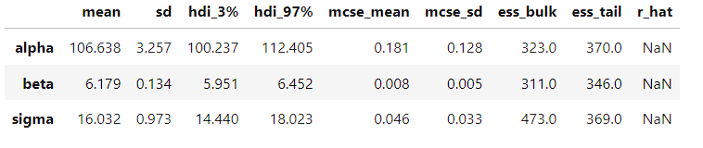

**Density Plots**

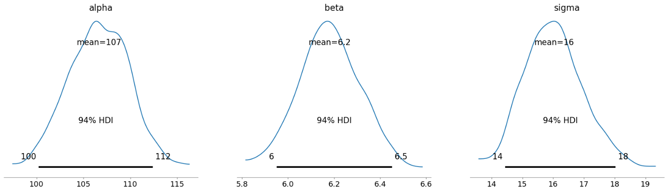

1. **(Code attached in APPENDIX)**

**Gelman-Rubin diagnostic plot**

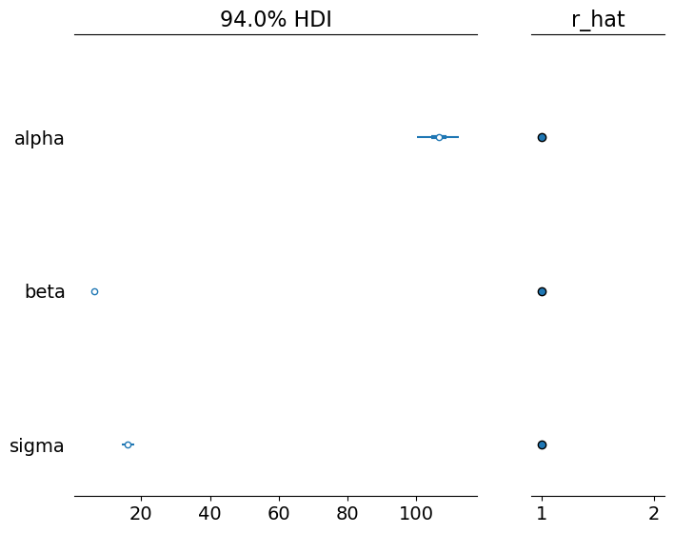

From the Graph we can see that the value for r_hat calculated in Gelman-Rubin Plot –

**alpha 1.001**

**beta 1.002**

**sigma 1.0**

These values suggest good convergence as value should be close to 1 and less than 1.1. This suggests that the chains have converged to a stable distribution. The HDI value also suggests that parameter estimates are also reliable and model is stable.

1. **(Code attached in APPENDIX)**

**Summary**

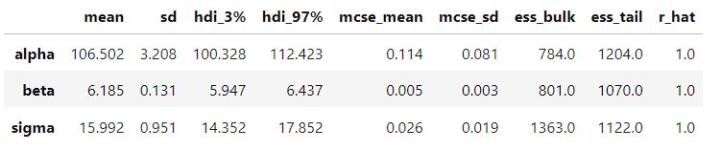

**Trace Plot**

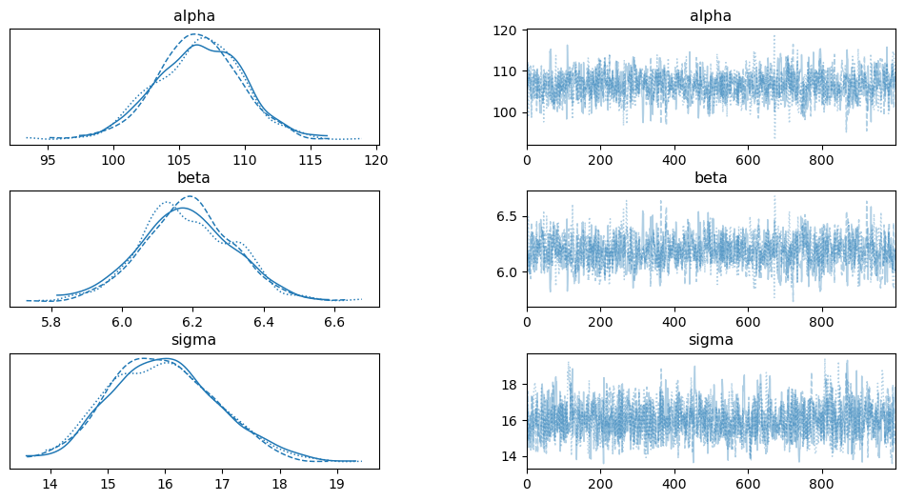

**Density Plot**

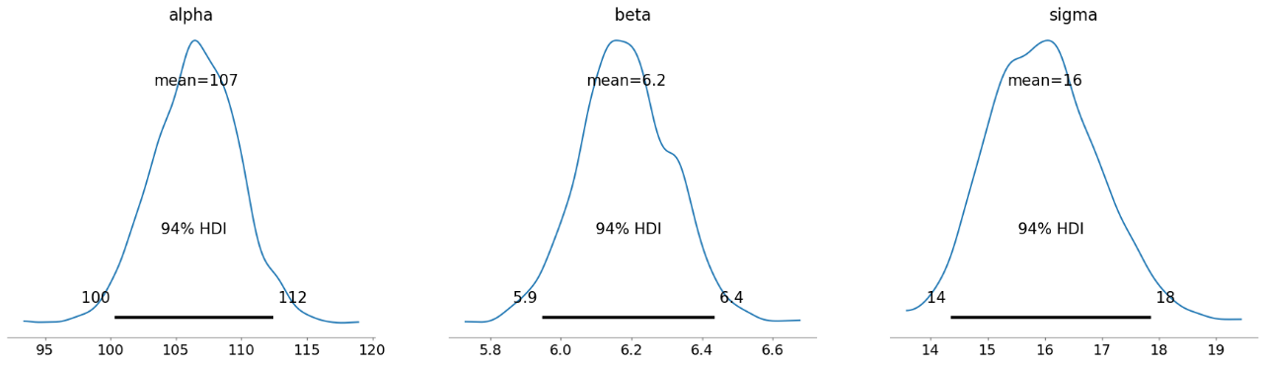

In Trace Plot, the normal bell-shaped curve shows that the 3 parameters have converged on a normal distribution as required for the Posterior distribution. The existence of a unimodal structure also behaves well for the Posterior distribution. This is good for convergence.

The parameter space also seems to be well covered. For the three parameters, the graph shows no patterns as well as the fluctuations lie close to their respective means meaning less variability.

The total of 3 chains and after their respective iterations seems to have converged.